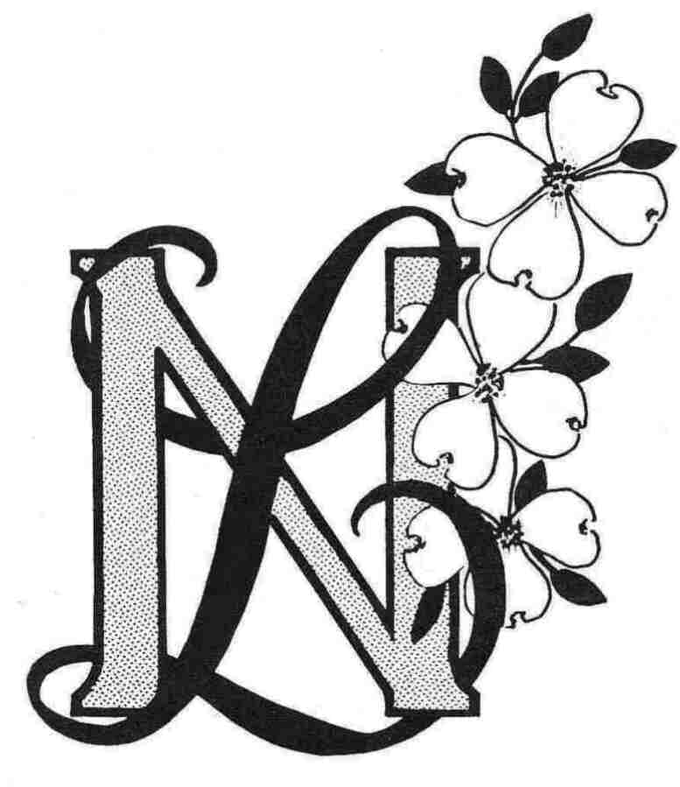
Newcomers Longtimers
Member Registration Form (Revised 5/31/22)
Membership Dues: $20.00

New Member____ Current Member Information Revisions____ Date________

(Please print)

Name_______________________________________________________________________

Spouse/Significant Other_________________________________________________________

Mailing Address_______________________________________________________________

City___________________________________ State____________ Zip__________________

E-mail Address________________________________________________________________

Phones: Home________________ Cell__________________ Other_________________

Birthday: Month _______ Day_______

Tell us about yourself. Do you have special skills/talents you would volunteer?______________

___________________________________________________________________________

How did you find out about Newcomers Longtimers? ______________________________

What are you interested in? Circle as many as you wish.

Everybody Bunco Ladies Bunco Happy Hour Dining Out Diners, Drive-ins and Dives Monthly Lunch

Book Club Hand and Foot Canasta Bridge Craftnooners Single Ladies Pickle Ball

Special Activities

Date__________________ Signature______________________________________________

Please return this form and dues to the Membership Chair:
Paula Constantini, 128 Park Circle, Lake Ozark, MO 65049

